**Angular JS – Navigation Menu**

**Ex. No. 8**

**Objectives:**

* Design a Navigation Menu for the website using angular JS.

**What to do by the students (Implementation)**

* Include Angular JS and Angular route links using script tag.
* Define the separate pages under type=”text/ng-template” using script
* Use ng-route to route to the respective pages based on the value of $routeprovider.
* Defining separate controllers for each application.
* In this application, users can navigate to the respective webpage using the navigation menu at the top. Calculator and To Do List are provided as samples to navigate.

**Expected output (sample)**

**Home page contain menus, such as Home, Calculator and To do List**

1. **When you select or click the Home menu**

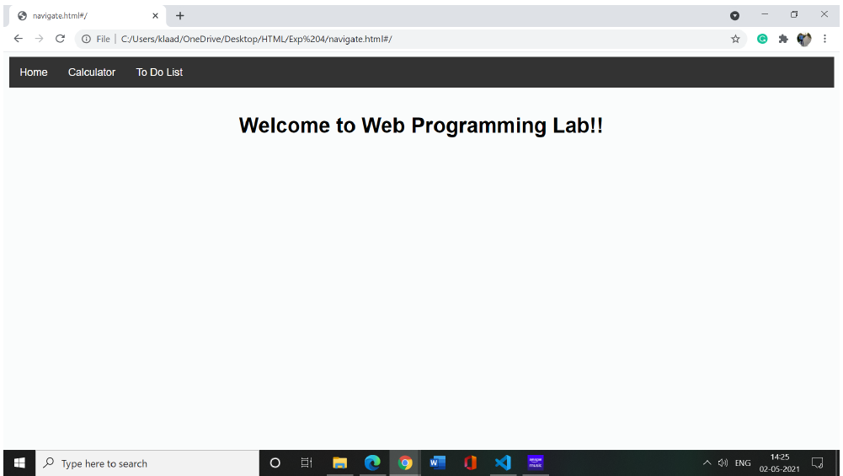

1. **When you select or click the Calculator menu**

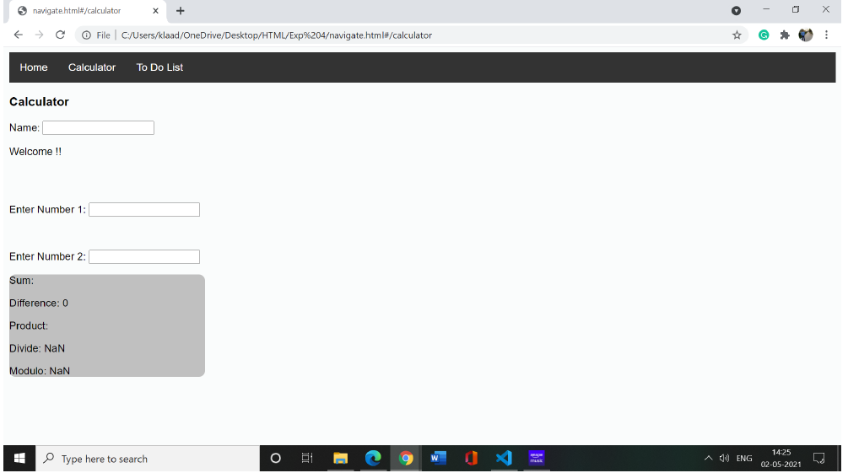

1. **When you click or select the To Do List menu**

